Mandatory Workplace Internship Applications
Dear Student,
Summer Term Internship Applications https://staj.sabis.sakarya.edu.tr will be carried out via the Internet. Create your internship application by following the steps below on the relevant link.

- Students https://staj.sabis.sakarya.edu.tr In order for the insurance transactions to be carried out smoothly , they must complete their internship applications by the deadlines specified in the table below . Applications made after the application deadlines specified in the table will not be considered.
- 1st year students cannot do internships.
- 2nd year students can do a single internship at the end of the spring semester,
- 3rd and 4th year students can do two internships at the end of the spring semester.

Internship period is twenty (20) working days (Saturday - Sunday Internship cannot be done on days and other holidays ). Forms that do not comply with the deadlines specified in the appendix will not be considered.

All information about the internship; From the link of Internship Transactions on the web address of the faculty and departments and https://staj.sabis.sakarya.edu.tr You can find it in the announcements section of the link. Be sure to read the department internship principles and department internship instructions in these links!

https://staj.sabis.sakarya.edu.tr TRANSACTIONS TO BE DONE BY OUR STUDENTS VIA THE LINK .

one- https://staj.sabis.sakarya.edu.tr Type the link in the address bar and click the "Sign In" link.
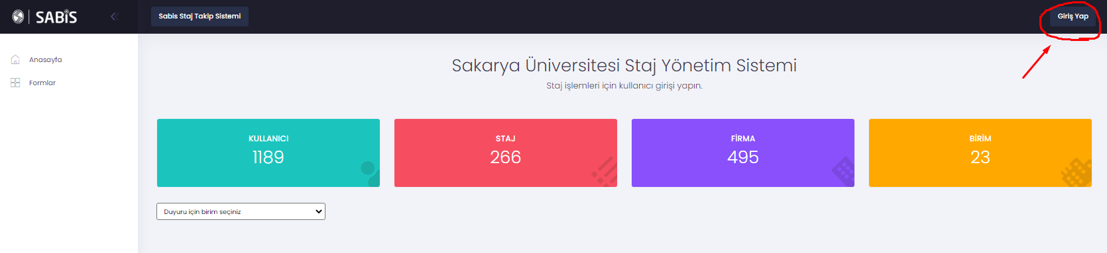
2- On the screen that opens , type your SABİS Username (b111210000) in the Username section and your SABİS password in the Password section and click on the “Login” link.
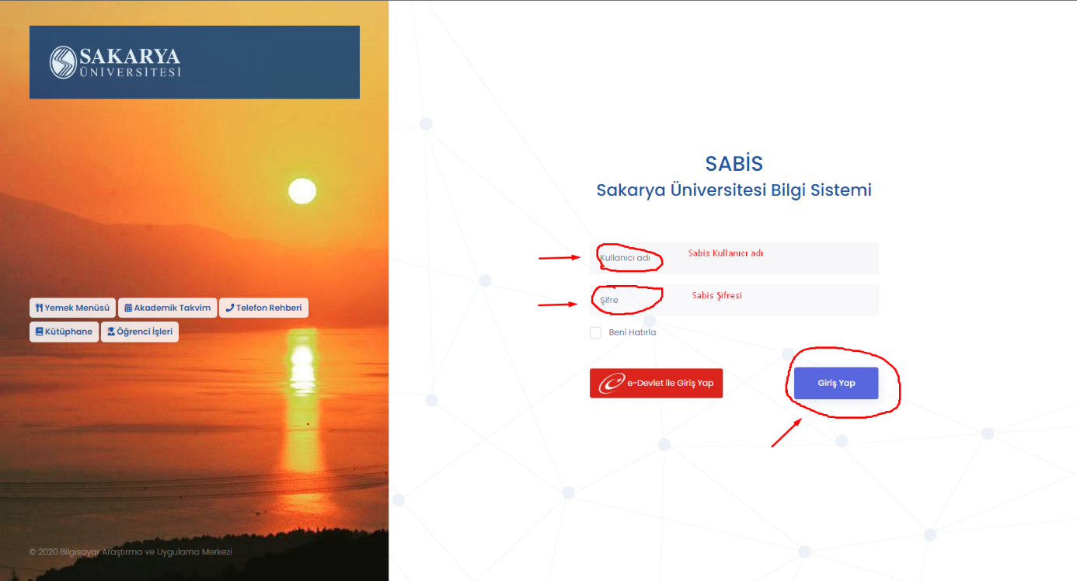
3- Department information is checked in the internship procedures section and the department the student is studying is selected.
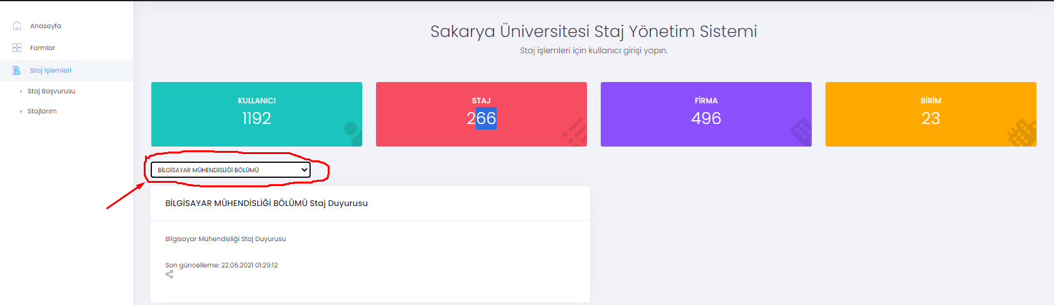

4- Click on the Internship Application link under the Internship Transactions Box. On the screen that opens, read the internship announcement text published by the "STEP 1" Department and proceed to Step 2 by clicking the "Next Step" icon.
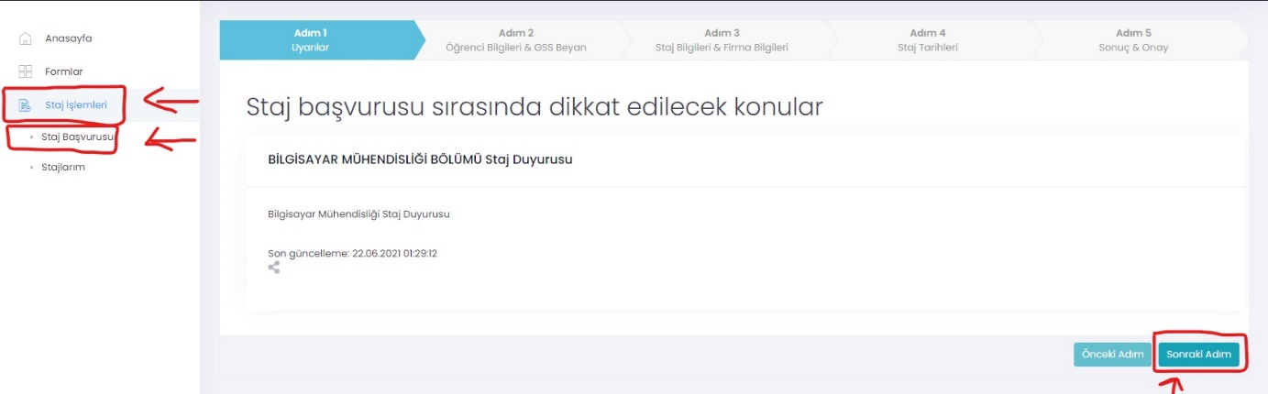
5- STEP 2: Student Information and GSS Declaration Please enter your phone number information in this field. You do not need to enter IBAN number information. Finally, tick the box that fits your situation regarding the General Health Insurance statement, click the “Next Step” icon and proceed to Step 3.
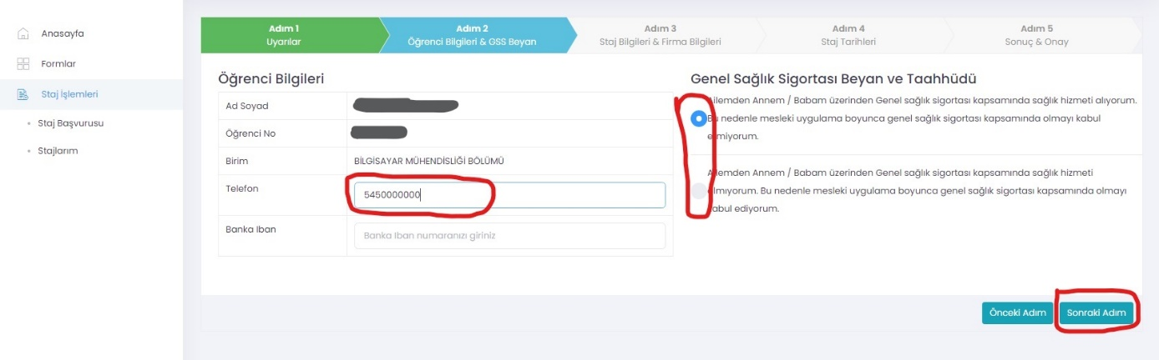
6- STEP 3: Internship Information Company Information Select the internship date that is appropriate for your situation from the internship dates defined by the Department in this field (by paying attention to the date and explanation "whether or not to take courses in summer school" as stated in the Department's internship announcement). Then , if the company you will be doing your internship is defined in the system in the "Select the Company to Do Internship (Add Company)" section, select the company and click the Next Step button.
NOTE: If the company you want to do internship is not in the list, please enter the information of the institution you want to do internship from the "ADD COMPANY" button and save it. In this case, the company you will do your internship will be approved by the internship commission. In this process, send an e-mail to the relevant commission member with a brief introduction about the company (number of employees, work subjects and whether there is an engineer in the company where internship will be done) . If the commission approves the company registration you specified, you can continue with your application. If the company is rejected, you cannot do an internship in this company.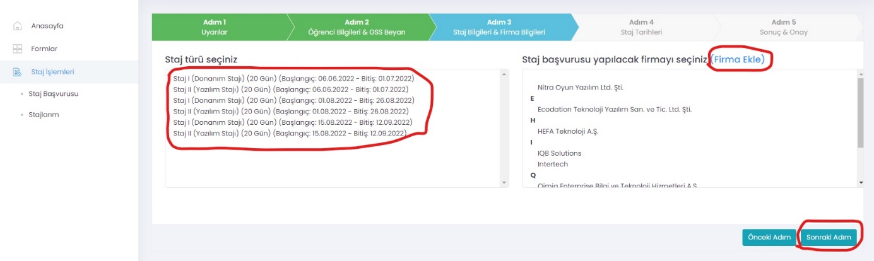
6-1 Add Company Enter the required information about the company in this field completely and click the Save button.
NOTE: After clicking the Save button, the company that you will do your internship will be approved by the internship commission. If the commission approves the company registration you specified, you can continue with your application. If the company is rejected, you cannot do an internship in this company.
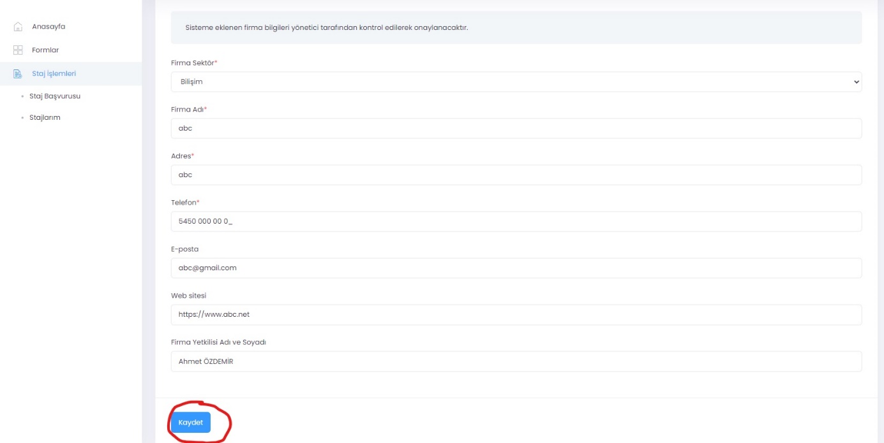
After pressing the “Save” button, the screen will change to the following situation. You can follow the approval status of the company on the Internship Application screen.
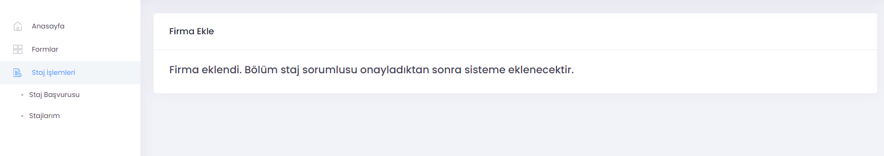
7- STEP 4: Internship Dates Check your Internship Start date in this field. (The internship end date will be calculated automatically.) Then, tick the commitment checkboxes related to the internship and click the Next Step icon to proceed to STEP 5.
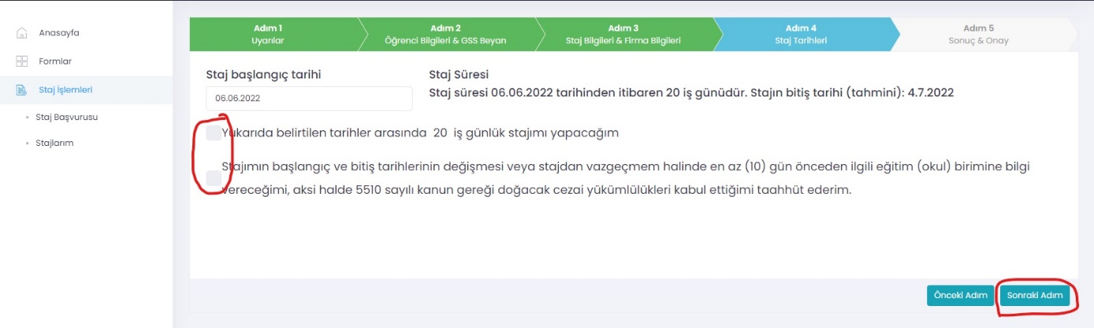

8- STEP 5: Result-Confirmation In this field, you can print or download the Internship Acceptance Form automatically created by the system . You must have the Internship Acceptance Form, which you print out, approved by the institution you want to do your internship with with a wet signature (Company Stamp and Seal, if any, must be done in this field.). Complete the first step of the application by clicking the "SAVE " button.
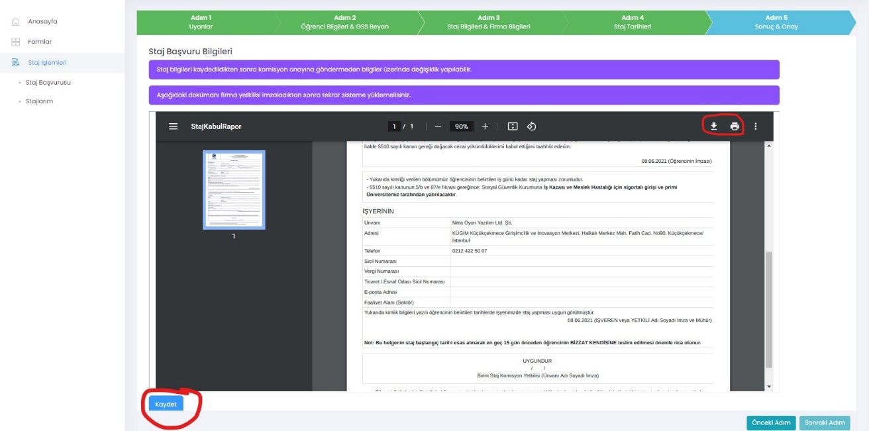
8.1- After the Internship Application SAVE process You can follow your application from the section of my internships on the left side of the main page. After clicking on this section, you will see a page like the one below. You can delete your application by clicking the DELETE button on this page.
DETAIL button, you can upload the approved version of the Internship acceptance form, which you printed out in STEP 5, to the system and submit your internship to the Internship Committee for approval.
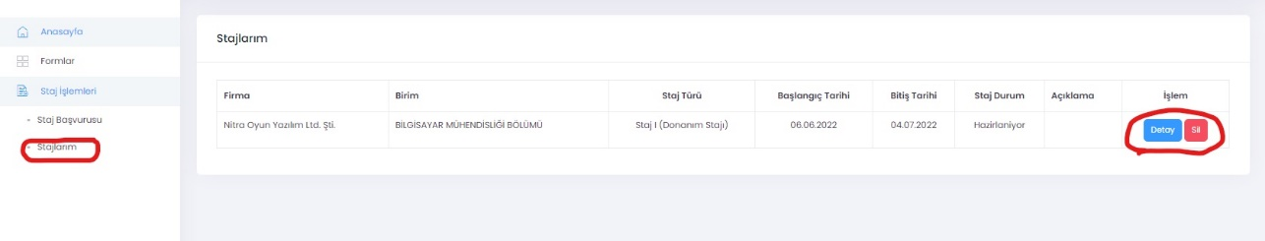
8.1.1- After clicking on the Detail Section, please complete the download from the " Browse " area , the image of which is shared below and marked in red, in order to upload the company-approved Internship Acceptance Form to the system .
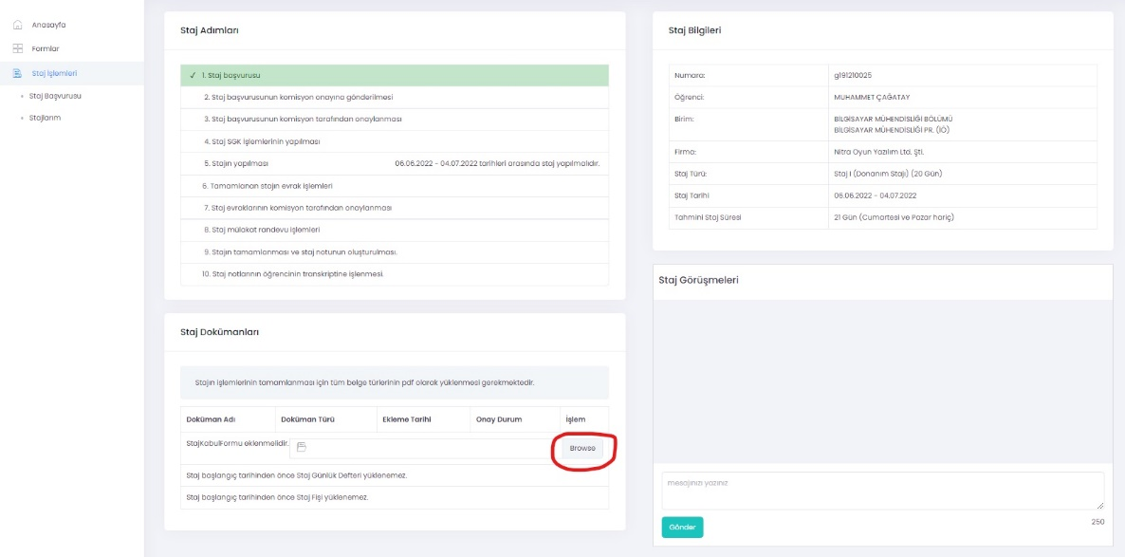
8.1.2- Sending the internship acceptance form you have uploaded to the Internship Commission for approval: After making sure that your internship acceptance form has been uploaded correctly as stated above (you can view the uploaded form by clicking the View Button, or you can reload the correct form via the delete button in case of an incorrect document upload) .) as shown in the picture below, you can send it to the Internship Commission for approval by clicking the Send for Approval button.
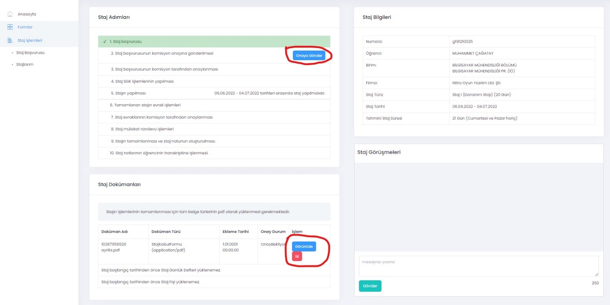
NOTE: The "Send for Approval" button will not appear without uploading the Application/Acceptance form to the system .
- If you submit it for approval, your application will be reviewed by the commission and, if deemed appropriate, will be approved or rejected. All of these processes will take place online and you do not need to bring any documents to the school.
- After your application is approved, you can access your SSI entry document from the "MY INTERNSHIP" menu.
- After this stage, you can do your internship on the approved dates.
- If your internship application is rejected, you must repeat the above steps and apply again.
- Book, the documents you need to fill at the end of the internship, Internship Evaluation Form (It will be uploaded to the internship slip section. This document is the document that the company evaluates you about the work and transactions you have done during the internship) . After the internship is over , you need to prepare it, scan it and upload it to the system. The upload process will be carried out through the buttons that will be active at the end of the internship under the internship acceptance form button at the bottom of the screen whose image is shared in section 8.1.2 .

